**Table of contents**

* Figure table
* Definition of GitHub terms

**Figuring table**

|  |  |
| --- | --- |
| Figuring number | step name |
| Figure 1 | Creating repository |
| Figure 2 | Creating new repository |
| Figure 3 | Creating new repository |
| Figure 4 | Creating new sub branch |
| Figure 5 | Creating new sub branch |
| Figure 6 | Compare |
| Figure 7 | Full request |
| Figure 8 | Add file |
| Figure 9 | Confirm merge |
| Figure 10 | Merge full request |
| Figure 11 | Document is merged |

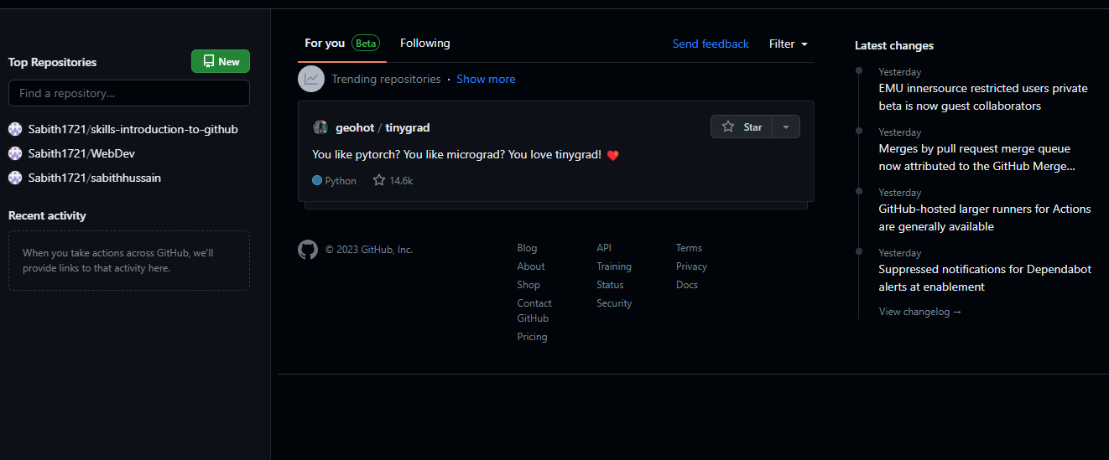

Figure

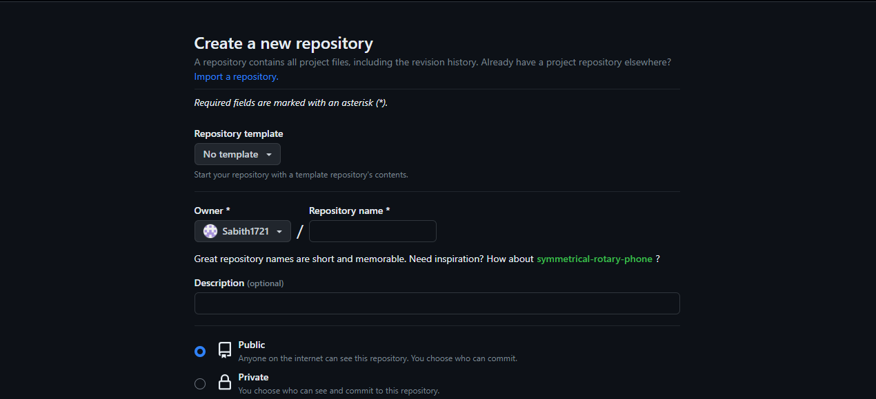

Figure 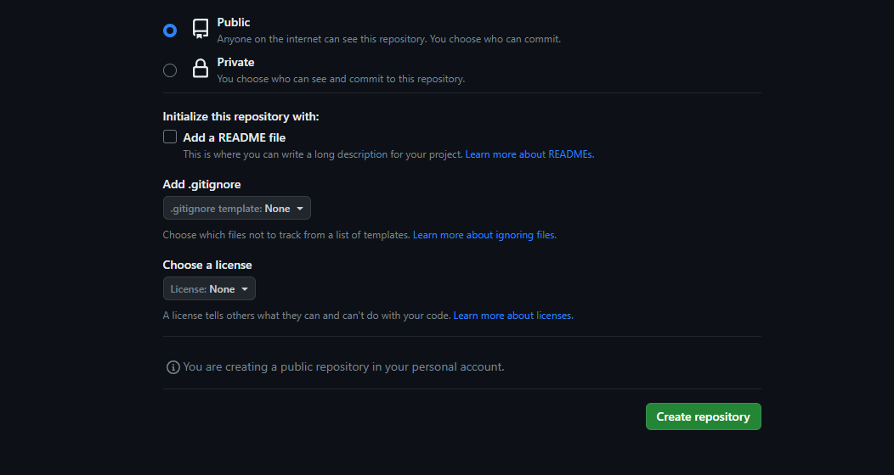

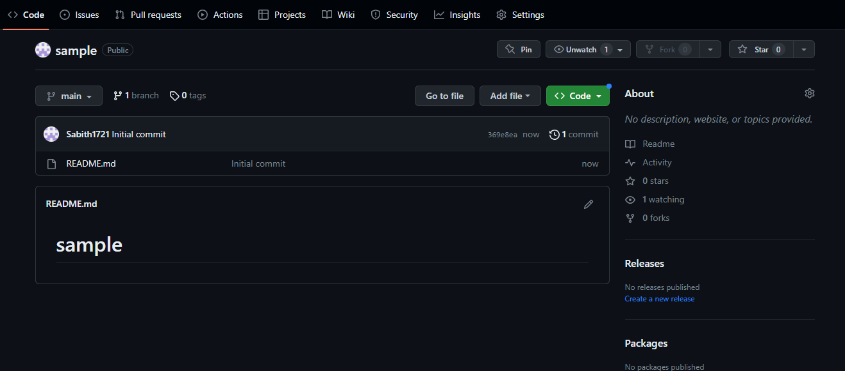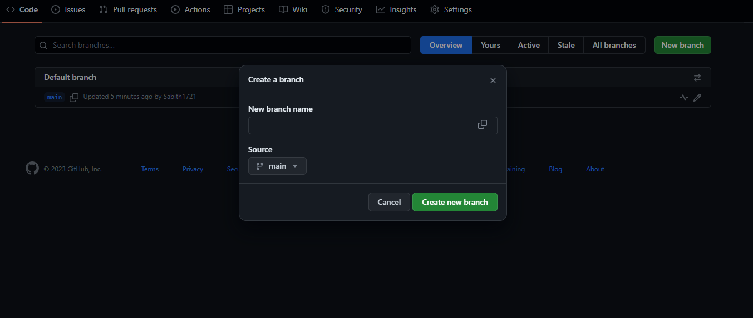

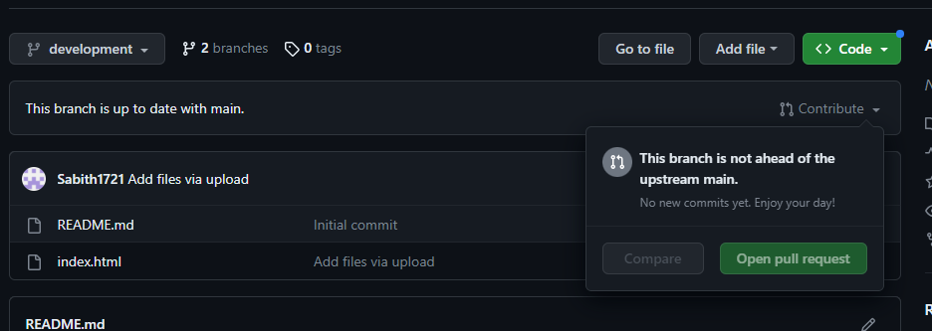

**COMMIT**

A commit is used to save changed to local repository, and the purpose of this is to keep track on what commit changes were made in the project and when they made.